**Abhiprajna: Accio Curiosité**

Organising Committee

Indian Institute of Science Education and Research (IISER)

Tirupati, Andhra Pradesh, 517619

1st August, 2025

**[Sponsor’s Name or Company Name]**

[Position, if known]

[Company/Organization Name]

[Address]

[City, State, ZIP Code]

**Subject: Sponsorship Request for Abhiprajna 2025**

Respected [Name],

We hope this message finds you well.

Abhiprajna: Accio Curiosité is an **inter-disciplinary national-level science competition organized by the students of IISER Tirupati**. Each year, we bring together some of the brightest STEM undergraduates from esteemed institutions across India to explore ideas, compete amongst themselves, and connect across disciplines. Abhiprajna is much more than just a quiz, it’s a celebration of scientific spirit, curiosity, and creative problem-solving.

We are writing to invite your esteemed organization to be a valued sponsor for the fifth edition of Abhiprajna, scheduled to be held on 4th and 5th October 2025 (tentatively).

The competition is held in two rounds: an online Prelims, followed by an on-campus Mains for the top-performing teams. The Prelims feature two rounds- a subject round and a theme round, for which Teams are required to solve through various subjective-type questions from Mathematics, Biology, Chemistry, and Physics. The Mains include three exciting segments: a classical presentation round, a mystery game, and a live quiz. Travel, accommodation, and food expenses for the qualifying participants will be covered by Team Abhiprajna.

What sets Abhiprajna apart from other science competitions is its **open-book format**, encouraging participants to consult textbooks, research papers, and other legitimate resources as they solve complex application-based questions. In this way, we cultivate analytical thinking, genuine scientific curiosity, and a deeper understanding of concepts. Our aim is to promote learning instead of rote memorization. Each edition is made further exciting by introducing an interdisciplinary theme, around which our rounds revolve.

This year, our theme is **“Chaos: Order in Disorder”**, where we will explore how randomness and structure coexist in nature and science. From fractals and strange attractors to turbulent weather systems and behavioral dynamics, we will dive into the thrilling realm where unpredictability meets structure, and the unexpected gives rise to patterns and extraordinary possibilities. This interdisciplinary theme connects various disciplines, linking science, technology, creativity, and human behaviour. It’s about finding patterns in the unpredictable, order in the disorder, and meaning in the chaos, making this edition more thrilling and exciting than ever.

Abhiprajna has grown significantly over the years. This year, we have registrations from over **350+ teams, comprising approximately 1500 participants from premier institutions including the IITs, NITs, BITS, IISERs, and other top STEM colleges across India**. Notably, we’ve also seen participation from institutions outside India, reflecting the event’s growing national and international reach and impact. This pie chart displays a distribution of number of registrations from each state, or country.

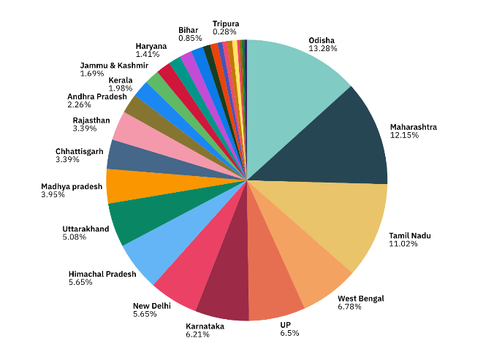

For making this edition successful, we seek your support and believe that this collaboration would be mutually beneficial.

**Partnering with our organization will offer your company:**

* High brand visibility across digital, print, and on-ground promotional channels
* Opportunities for direct engagement with a vibrant student community from IISER Tirupati, IIT Tirupati, and beyond.
* Opportunities for product showcases or promotional stalls during the on-campus event
* Acknowledgment in brochures, banners, stage mentions, and media coverage

**IISER Tirupati has over 1300 students and 75 faculty members**, and we share a close association with **IIT Tirupati (located just 3 km away)**, which adds over 1,500 additional active participants in our events. With this vibrant community of over 4,000 students, faculty, and staff, your brand will reach enthusiastic potential customers and learners.

We have curated **multiple sponsorship tiers with flexible benefits, and are also happy to customize packages as per your objectives.** We would be delighted to provide you with more details and explore how we can collaborate**. Please find attached our sponsorship with more details for your reference.** You can reach us via:-

Email: abhiprajna@students.iisertirupati.ac.in

Phone: 90217 51705 / 83061 05953 / 63746 08230‬‬‬‬‬

We look forward to the possibility of partnering with your esteemed organisation.

Warm regards,

Anushka Semalty and Agniwesh Y. Ghode

Co-Coordinators

Abhiprajna Organizing Committee